S.A.L.V.E. International – What is Permaculture?

These 3 lessons are suitable for students aged 11-13

Timing: 3 lessons x 60 minutes

Learning Objectives:

* Plan the structure of a formal letter to persuade an audience of the importance of an issue
* Summarise case studies to add support to ideas or an argument
* Use literary techniques such as rhetorical devices to give impact to the letter
* Write a formal letter, using good structure and persuasive writing techniques, to persuade an audience of a topic

**Letter writing**

This session guides students through through the use of persuasive writing techniques and how to structure a formal letter. The students are introduced to S.A.L.V.E. International and the permaculture work we do in Uganda with street connected children. The students then complete multiple activities to practice the techniques.

This lesson also supports the citizenship, PSHE and geography.

A BIG thank you from S.A.L.V.E.This resource has been designed by S.A.L.V.E. International, a charity that works with children living on the streets in Uganda. We are so excited you’re interested in using our resources to raise awareness about children’s rights and children living on the streets and thank you in advance for taking the time to teach your pupils about these issues! We value your feedback so don’t hesitate to get in touch at info@salveinternational.org.

|  |  |  |  |
| --- | --- | --- | --- |
|  |  |  |  |
| **Activity** | **Resources** | **Suggested Timing** | **Notes and Differentiation** |
| **Lesson 1:** What is permaculture? |  |  |  |
| **Activity 1:** what fruit/vegetables are growing | Powerpoint with obscured fruit/veg and answer slides | 10mins |  |
| **Activity 2:** watch permaculture video | https://www.youtube.com/watch?v=b5dahyWSu0o | 10mins |  |
| **Activity 3:** Complete fill in the gaps activity | Worksheet ‘what is permaculture’ | 10mins | When completed the worksheet will support less able students to complete later tasks |
| **Activity 4:** Read Lucky’s story | Print Lucky’s story on A3 sheets of paper. Students work in groups to highlight | 15mins | Mixed ability grouping will support less able students to complete the task. |
| **Activity 5:** Key word match up | Students complete the worksheet matching the key words to their definitions. | 15mins | Definitions will support lower ability students as they can then reference the list during the other lessons. |
| **Lesson 2:** Permaculture and Climate Change |  |  |  |
| **Activity 1**: Introduce the climate summit | Powerpoint slides | 10min |  |
| **Activity 2**: key term bingo or students match key terms to definitions using the worksheet | See teacher definitions/worksheet | 10min | Definition/key term matching activity can be used instead to support lower students as they can then reference the list during the class |
| **Activity 3:** Read letter written by the climate coalition. Students annotate it to show the persuasive writing techniques used | Print the letter on A3 paper so the students can easily annotate it in pairs/groups.  Some techniques are highlighted on the following slide- although there are more that the children may find. | 15mins | Mixed ability grouping will support less able students to complete the task. |
| **Activity 4**: Case study ‘learning lifelong skills’ | Print the case study ‘learning lifelong skills’ on A3 paper. Split the class into groups of approximately 3. Each group uses the case study to write 3 information points- they should try to use persuasive writing techniques for each one. | 15mins | Higher ability |
| **Activity 5:** Just a minute | A student is given the key words in an envelope. They have 1 minute to describe as many key words as possible. The rest of the class guesses the key words. Continue with another student until all the key words are completed. | 10mins |  |
|  |  |  |  |

|  |  |  |  |
| --- | --- | --- | --- |
|  |  |  |  |
| **Activity** | **Resources** | **Suggested Timing** | **Notes and Differentiation** |
| **Lesson 3:** Permaculture, Climate Change and COP28 |  |  |  |
| **Activity 1**: True/False thumbs up quiz to remind students of what permaculture is |  | 10min |  |
| **Activity 2**: Students discuss issues with the layout of the example letter then feedback. Then use PowerPoint to show how a formal letter should be constructed |  | 10mins |  |
| **Activity 3:** Students are given the success criteria for their letters. 5mins of discussion time with a partner. Feedback 3 main points they want to include in their letter |  | 15min |  |
| **Activity 5:** Students complete the letter planning worksheet |  | 25mins | Leave time to discuss the homework task (writing the letter out in full) |
| **Next lesson collect the letters and send them to:**  House of Commons, London, SW1A 0AA |  |  | If you miss the cut-off date for sending the letters to COP28 the letters can be sent ready for COP29. |

Resources

Photo Credits

**Photo credits for PowerPoint presentation:**

Slide 1 - (Clockwise from top left): 1. Jonathan McIntosh 2. Tanvirul Islam 3. Zirland 4. Peter Rimar 5. Biswarup Ganguly 6. Esther Dobson 7. Predrag Bubalo 8. Esther Dobson 9. Biswarup Ganguly 10. Sumanth Garakarajula

All other images taken from [www.pixabay.com](http://www.pixabay.com)

Name……………………….….

**Worksheet: What is Permaculture?**

Watch the video and note down the three main design ideas in Permaculture:

1. ……………………………………………………………………………………….

……………………………………………………………………………………….

1. ……………………………………………………………………………………….

……………………………………………………………………………………….

1. ……………………………………………………………………………………….

……………………………………………………………………………………….

chemicals resources goats labour culture increasing water minimize sustainable climate planning matoke

Permaculture is about doing the right thing! The word ‘Permaculture’ comes from two words Permanent and _____________. Permanent in this case refers to the idea of producing agricultural products in a sustainable way (or a permanent way). ______________ , in Permaculture, draws on the two uses of this word in English- the idea of cultivating something and the idea of a ‘way of life’.

Permaculture teaches _______________ farming methods that are vital for a world with an ______________ population and changing _____________.

The technique is based on using the ____________ you have in the best possible way. It aims to ________________ waste, human _____________ and energy use.

Some important parts of permaculture are _____________ how best to use the land available, considering how to best collect and use ____________ and thinking about how to control pests without using _____________.

At our farm we grow lots of things including:

* _______________
* Mangoes
* Garlic
* Aubergine
* Tomatoes
* Herbs
* Potatoes

We also raise animals, particularly:

* _______________
* Chickens

**Lucky’s story\***

Lucky was the oldest of four children. Aged 6, his parents separated, and his mother moved to a town 10km away with all his siblings. His father moved to Kampala (the Capital city) where he remarried. After 3 years his father decided to move Lucky to Kampala to live with him and his stepmother. His father then got another wife, leaving Lucky with his stepmother. She mistreated him so badly that it forced him to run to the streets of Kampala. Life was really tough on the streets, so Lucky decided to go home.

However, the situation at home had worsened. His stepmother believed Lucky’s mother had bewitched her own two children and she blamed Lucky. She was angry and punished him, denying him food and making him do difficult work. He once again fled to the streets of Jinja where the social workers from S.A.L.V.E. met him. They persuaded him to attend the Drop In Centre for counselling; however, he was scared and struggled to trust us and ran away after one day. The team searched for him and encouraged him to return.

**Returning to S.A.L.V.E.**

After several counselling sessions at the Centre, he was transferred to the S.A.L.V.E. residential site and lived at the Halfway Home where he was welcomed by staff who showed him great love and care. They gave him a variety of tasks to do and Lucky showed a keen interest in the permaculture work. Through these lessons he learnt many skills and developed knowledge that he plans to use in the future upon return to his mother. Some of the skills he acquired at the S.A.L.V.E. site include growing and maintaining different crops like maize, vegetables and beans intercropped together, as well as animal health management. Lucky is so thankful to S.A.L.V.E. for the great work they have done with him.

**No Street Called Home**

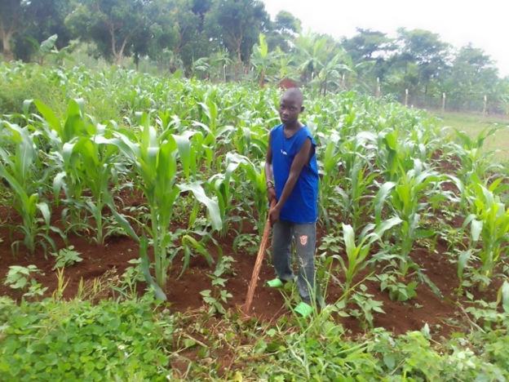We at S.A.L.V.E. believe these children and their families need support to enable them to live a happy life because there is ‘No Street Called Home’. We achieve this through counselling and education, both at the S.A.L.V.E. residential site and at the family home with follow-ups. Every child should have the opportunity to be raised in a suitable way that enables them to develop their potential and to grow into a responsible and good person.

*Name of child has been changed in line with our Child Protection Policy

By Peter a permaculture teacher at S.A.L.V.E. International

**Permaculture Keywords**

Draw a line from the key word on the left to the definition on the right.

|  |  |  |
| --- | --- | --- |
| **Culture** |  | Another word for farming. |
| **Permanent** |  | The management of animals/plants/fungi that have a negative effect on the growing of crops or the raising of animals |
| **Waste** |  | Making sure that every human on the planet has a fair amount of the produce that are farmed. |
| **Pest control** |  | Two meanings in permaculture-the idea of preparing and using land for growing crops and the idea of a ‘way of life’. |
| **Matoke** |  | Results of a process (Permaculture for example) that are no longer useful. |
| **Sustainable** |  | All the people who live in a particular place, e.g. the world. |
| **Stigma** |  | Intended to last or to remain. |
| **Produce** |  | When someone is seen as shameful or have been disgraced. |
| **Fair share** |  | Living in a sustainable society. |
| **Land** |  | The collective name for products that have been grown on a farm, or have come from animals raised on a farm. |
| **Population** |  | A plant similar to banana. |
| **Agriculture** |  | Something that can meet the needs of people today while ensuring future generations have access to natural resources. |
| **Earth care** |  | Farming in a harmonious way with nature. |
| **People care** |  | Ground or soil used in farming. |

**Key word Answer sheet**

|  |  |
| --- | --- |
| **Culture** | Two meanings in permaculture-the idea of preparing and using land for growing crops and the idea of a ‘way of life’. |
| **Permanent** | Intended to last or to remain. |
| **Waste** | Results of a process (Permaculture for example) that are no longer useful. |
| **Pest control** | The management of animals/plants/fungi that have a negative effect on the growing of crops or the raising of animals |
| **Matoke** | A plant similar to banana. |
| **Sustainable** | Something that can meet the needs of people today while ensuring future generations have access to natural resources. |
| **Stigma** | When someone is seen as shameful or have been disgraced. |
| **Produce** | The collective name for products that have been grown on a farm, or have come from animals raised on a farm. |
| **Fair share** | Making sure that every human on the planet has a fair amount of the produce that are farmed. |
| **Land** | Ground or soil used in farming. |
| **Population** | All the people who live in a particular place, e.g. the world. |
| **Agriculture** | Another word for farming. |
| **Earth care** | Farming in a harmonious way with nature. |
| **People care** | Living in a sustainable society. |

Just a minute- key words

|  |  |
| --- | --- |
| Culture | Land |
| Permanent | Population |
| Waste | Agriculture |
| Pest control | Earth care |
| Matoke | People care |
| Sustainable |  |
| Stigma |  |
| Produce |  |
| Fair share |  |

## Learning Lifelong Skills

Teaching practical skills to the children undergoing rehabilitation is at the core of the [Permaculture programme](https://www.salveinternational.org/salve-explained/permaculture/) being run at S.A.L.V.E. International’s 5-acre site. Most of them have spent a long time away from their homes living on the streets and find it hard to cope with the roles expected of them when they return. Most of the children are from rural settings where agriculture is the main economic activity. Therefore developing agricultural skills enables these children to reintegrate more easily into their homes and communities. With our Permaculture programme we go further, by providing an approach to production that is more sustainable than the way conventional farming is carried out in most village settings.

**Overcoming Challenges**

Some children dislike being taught these skills at first, which is to be expected. They are seen as boring and the children have learnt to make quick and easy money whilst on the streets selling scrap metals, carrying plastics and removing rubbish etc. After this, they don’t want to go back to a life digging the land and waiting for crops to grow in order to make money. Some have even been mistreated by parents and guardians through unequitable sharing of proceeds from gardens back home. Such disappointments, coupled with fear, cause discouragement.

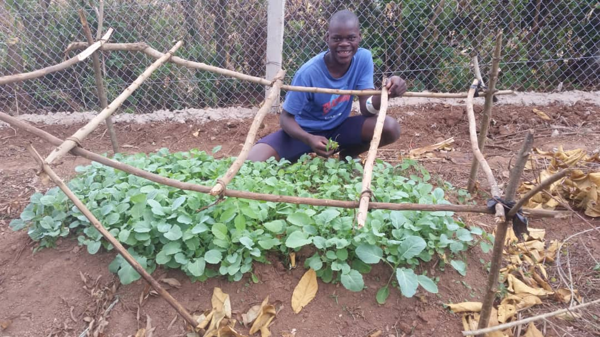Our approach is to introduce them to a newer process of land cultivation. It begins with drawing up plans then mapping the area. This is followed by an in-depth overview of the available resources including the soil, water, plants, and wildlife. This arouses their interests because it helps them appreciate and develop a greater understanding of their environment. After this, the children stop running away from the farm work and choose to spend more time with their teachers to find out more. We encourage them to draw sketches and plan as much as possible. As well as being fun, this challenges their perception of farming as a job for the uneducated to a vocation of wisdom.

**Sam’s Story**

Sam* started coming to our classes at S.A.L.V.E. and shared that he was interested in vegetable farming a crop not grown in his home district. He wanted to create a successful nursery and at first thought we wouldn’t help. However, the teachers dedicated more time to Sam and his close friends for this project.

Initially in class, we taught the importance of starting vegetable crops from a proper nursery bed.  Next we carried out practical sessions where the group built their bed and planted collards (similar to cabbages) in it. The students all enjoyed this creative learning process.

After this Sam asked the teacher if he could create a nursery alone, without the help of the group, as he wanted to challenge himself and develop his learning. He began by using the correct tools to build his bed, constructed a shade around it and then planted his crops. After a few weeks, Sam was really happy to see his sprouts growing so vigorously. Currently, he is transplanting his plants to the main gardens.

We are so grateful to provide Sam with these skills and are sure that once he gets resettled, he will take these skills home and help transform his community. Transformation takes various stages and through the passing of knowledge from one person to another, change occurs.

Here at S.A.L.V.E International, imparting skills is our way of life. We thank all our supporters and ask stakeholders to continue standing with us in our endeavour to encourage children away from the streets and become well rounded individuals when they return home.

*Name of child has been changed in line with our Child Protection Policy

**Persuasive writing Techniques with Definitions**

* **Alliteration**- Using a series of words with the same first letter
* **Fact**- Something true
* **Rhetorical question-** A question that is not designed to be answered but should make someone think
* **Repetition**- repeating a word or phrase two or more times to increase its impact
* **Emotive Language** – use of word and phrases that produce an emotional response
* **Statistics-** numerical data
* **Anecdote-** a short story about a real person or event
* **Hyperbole-** an exaggerated statement that’s not meant to be realistic but is used as a figure of speech
* **Personal pronouns**- he, she, it, they, him, her etc
* **Power of three**- using the same or similar image or idea three times
* **Superlative**- words ending in ‘st’ that shows the upper/lower limits of something e.g. highest, best, happiest
* **Oxymoron**- two contradictory words found in sequence or in a phrase ‘less is more’ ‘you’ve made a fine mess’.

**Key Terms for Persuasive Writing**

|  |  |  |
| --- | --- | --- |
| **Alliteration** |  | Two contradictory words found in sequence or in a phrase ‘less is more’ ‘you’ve made a fine mess’ |
| **Fact** |  | Words ending in ‘st’ that shows the upper/lower limits of something e.g. highest, best, happiest |
| **Rhetorical question** |  | Using the same or similar image or idea three times |
| **Repetition** |  | Something true |
| **Emotive Language** |  | Numerical data |
| **Statistics** |  | A short story about a real person or event |
| **Anecdote** |  | Use of word and phrases that produce an emotional response |
| **Hyperbole** |  | Repeating a word or phrase two or more times to increase its impact |
| **Personal pronouns** |  | He, she, it, they, him, her etc |
| **Power of three** |  | Using a series of words with the same first letter |
| **Superlative** |  | A question that is not designed to be answered but should make someone think |
| **Oxymoron** |  | An exaggerated statement that’s not meant to be realistic but is used as a figure of speech |

Draw a line from the key word on the left to the definition on the right. Use these definitions to help you to write your letter later in the lesson.

**Prime Minister Boris Johnson,**

**This is your chance to leave an historic legacy.**

Wild weather, raging fires, deadly floods and rising seas are sweeping the globe. They’re caused by human-made emissions and the destruction of nature, and they’re devastating lives here and across the world.

The damage we’re doing to rainforests, oceans and our own countryside means there are some sights our grandchildren will never see and some cultures that will be lost forever.

Lives and livelihoods are already being torn apart in communities on the frontlines of the crisis.

**The public’s concern about climate change has reached an all-time high** [1]**. We expect you to protect our future.** **Your success or failure will be written about in the history books.**

You could be remembered for agreeing a global plan to **cut emissions to stop the world heating** by more than 1.5℃, and leading by example in the UK by drawing the fossil fuel era to a close.

You could be remembered for leading global commitments to **restore and protect nature** in the next decade, and leading by example in the UK by building back our woodland and peatlands that capture carbon and slow down climate change.

You could be remembered for ensuring there is **financial support to meet the scale of the impacts faced by the people and communities most affected by climate change globally,** and leading by example in the UK by investing to create new green jobs.

**Failing to face the biggest existential threat since World War II will be no legacy at all. Will you deliver an historic climate deal that respects the contract between this generation and the next?**

**Yours sincerely,**

**The Climate Coalition, representing 22 million people across the UK**

https://www.theclimatecoalition.org/open-letter-cop26

* Anecdote
* Hyperbole
* Personal pronouns
* Power of three
* Superlative
* Oxymoron

**Persuasive writing techniques to use:**

* Alliteration
* Fact
* Rhetorical question
* Repetition
* Emotive Language
* Statistics

Yours faithfully/sincerely…………………………....

Your letter must include the following:

* What permaculture is
* How and why S.A.L.V.E uses permaculture to help street connected children
* Why permaculture should be encouraged by the UN
* **The letter should be 1 A4 sheet long**

<https://www.salveinternational.org>

www.cop28.com

Paragraph 3 Summarise your main points for writing the letter

…………………………....…………………………....…………………

…………………………....…………………………....…………………

…………………………....…………………………....…………………

…………………………....…………………………....…………………

…………………………....

…………………………....

…………………………....

Paragraph 2 Add more detail. Add information about successful case studies here

…………………………....…………………………....…………………

…………………………....…………………………....…………………

…………………………....…………………………....…………………

…………………………....…………………………....…………………………....…………………………....…………………………....………

…………………………....…………………………....…………………

…………………………....…………………………....…………………

…………………………....…………………………....…………………

…………………………....…………………………....…………………

Paragraph 1 Explain why you are writing the letter

…………………………....…………………………....…………………

…………………………....…………………………....…………………

…………………………....…………………………....…………………

…………………………....…………………………....…………………

…………………………....

…………………………....

…………………………....

Dear…………………………....

Date………………………….

Your address

…………………………....

…………………………....

…………………………....

…………………………....

