



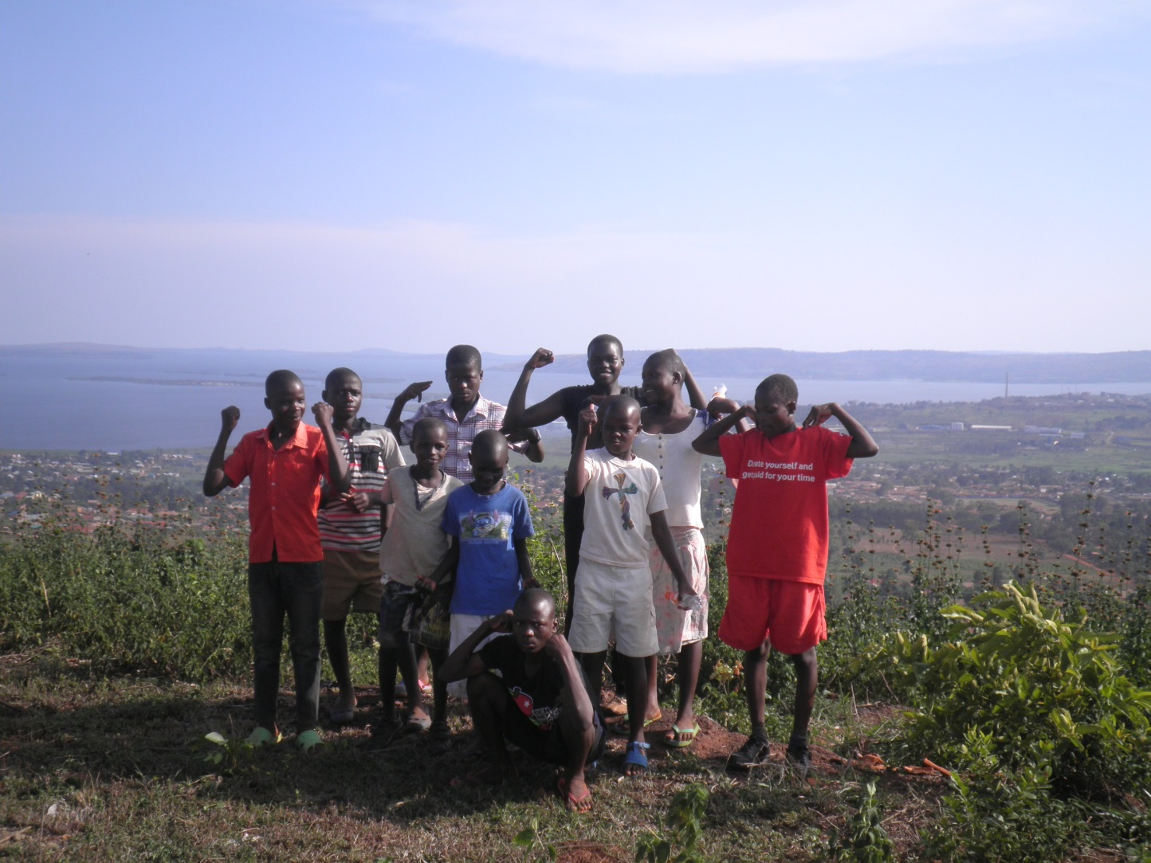

This Session

The lessons engage with learning objectives from subjects including Citizenship, PSHE, English and Geography.

English

**Speaking and listening:** A variety of group discussions stimulate interaction (learning to speak confidently and listen to what others have to say) and give pupils the chance to organise and express thoughts and feelings.

**Reading and comprehension**: Neya and Ajay’s case-study gives the opportunity to pupils to develop their skills in learning to read confidently and independently, working out the meaning of straightforward texts and gaining familiarity with non-fiction texts.

**Writing:** Task 2 in Part 2 allows children to improve spelling, handwriting and presentation skills.

Global Citizenship and PSHE

**Knowledge and Understanding:** Lesson as a whole raises awareness of rich and poor, similarities and difference between people, and sense of the wider world.

**Skills**: Encourages the development of an enquiring mind, gives opportunity to begin to state opinions, facilitates empathising and responding to others, and making links between our lives and the lives of others.

**Values and Attitudes**: Develops interest in and concern for others, stimulates engagement with social justice and what is right and wrong.

Geography

**Knowledge and understanding:** Helps develop an increased sense of the wider world and similarities and differences between countries, as well as starting to let children engage with human and social features of other countries.

**Skills:** Use secondary sources of information

|  |  |  |
| --- | --- | --- |
| **Activity** | **Resources** | **Suggested Time spent** |
| **Part 1/Activity 1:**  The cards below introduce children to the idea of child rights by helping them to consider the difference between a “want” and a “need”. The basic needs that should be met so children and young people grow up to reach their full potential are enshrined in the UN Convention on the Rights of the Child. The 18 cards divide as seen below – the appropriate Article from the Convention is noted beside each of the ‘needs’  In pairs or fours, students should organise the cards from “Most Important” to “Least Important”. They should then pick out what they believe are the 6 most important cards.  As a class feedback on this activity and compare groups’ decisions – ask why they decided to put certain cards above others | Print and cut out cards (1 set to each pair/group) | 10 minutes |
| **Activity 2:**  Discuss the difference between a WANT and a NEED, thinking about a need as something required for children to grow healthily and happily.  Pupils again divide the cards into two categories: WANTS / NEEDS. This time, explain that the things children NEED, they have a *right* to have. Children’s NEEDS should be met because they cannot provide most of them for themselves but rely on adults.  Feedback in class, using table below as reference for which cards should be in NEEDS or WANTS.  Ask how we should make sure all children’s needs are met, encourage answers such as:   * Ensuring accessibility to healthy food and clean water * Helping those without housing to find safe housing (e.g. through charities or government help) | Same as above | 15 minutes |
| **Activity 3:**  Hand out Neya and Ajay’s story and give pupils time to read it independently.  Discuss as a class:   * Which of Neya and Ajay’s needs are not being met? * Is it fair that they live on the streets and some of their needs are not met? | Neya and Ajay’s story (below). 1 per child | 10/15 minutes |
| **Part 2/Activity 4:**  Neya and Ajay are just two of millions of children living on the street around the world. This part of the lesson introduces children to the global issue of children living on the street.  Use the introductory PowerPoint (Lesson PowerPoint) to explore:   * Who are children on the street? * Where are children on the street? * Why are there children on the street?   These questions will be explored in more depth in the following three lessons. (You can print the slides and notes together by going to ‘Print Preview’ and selecting ‘Notes’ format). | Lesson PowerPoint | 5/10 mins |
| **Activity 5:**  The second to last slide is a picture of Betty, who lives on the streets of Uganda.  Create a mind map on the board and ask pupils to each say one thing they would miss if they were like Betty – encourage thinking back to the earlier needs/wants. | White/blackboard | 5 mins |
| **Activity 6/Plenary:**  Ask pupils to reflect on today’s lesson and have each table/group come up with 1 thing they will take away (either something they have learnt, what they could do in the future to help children living on the streets etc) | N/A | 5 mins |

|  |  |
| --- | --- |
| NEEDS | WANTS |
| * Clean water (Article 24) * A home (Article 27) * Education (Articles 28 & 29) * Have your say (Article 12) * Medical care (Article 24) * Nutritious food (Article 24) * Play (Article 31) * Practise beliefs, culture and language (Article 30) * Protection from abuse (Article 19) * Protection from discrimination (Article 2) | * Bicycle * Fashionable clothes * Holiday trips * Pocket money * Personal computer * Mobile phone * Television * Own bedroom |

|  |  |  |
| --- | --- | --- |
| **page4image46174064**Simply punishing students for bullying will not address ...**Protection from abuse** | **page4image46142544Clean water** | page4image46143584**A home** |
| **Education**  This Photo by Unknown Author is licensed under CC BY-NC-ND | **Have your say**  This Photo by Unknown Author is licensed under CC BY | **부서진 만화 주연 · Pixabay의 무료 벡터 그래픽Medical care** |
| **Healthy food**  This Photo by Unknown Author is licensed under CC BY-NC | **Play**  page4image46143792 | **Practise beliefs, cultures and language**  **Speech Bubbles Free Stock Photo - Public Domain Pictures** |
| page5image46148576**Protection from discrimination** | **Bicycle**  **Need! – GROW UP MESSY – The Diary Of A Rolling Stone** | **Fashionable clothes**  page5image46148368 |
| **Africa African Airplane · Free vector graphic on PixabayHoliday trips** | page5image46148784**Pocket Money** | **Children Room by AimanStudio on DeviantArtOwn bedroom** |
| **Personal computer**  This Photo by Unknown Author is licensed under CC BY-SA-NC | **TV**  This Photo by Unknown Author is licensed under CC BY-SA-NC | **Mobile phone**  **Kostenlose Vektorgrafik: Zelle, Handy, Mobil, Flip Telefon ...** |

**Most Important**

**Least Important**

**Needs**

**Wants**

Neya and Ajay

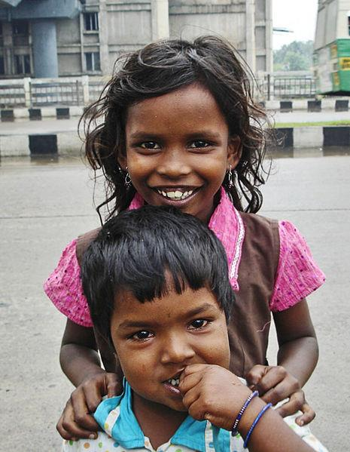

This is Neya and Ajay. They are from India.

Neya is 10 years old, and lives on the street with her brother Ajay who is 6.

They used to live in a house and go to school, but after their mum lost her job at a factory they had to move on to the street and start working to earn money. Neya works washing car windows on the main road. Ajay collects rubbish and scrap metal.

Neya says sleeping on the streets is scary and she would like to go back home and play with her friends. Sometimes people are nasty to them and think they’re bad people because they live on the street.

**Accreditation:**

Case study: The case study used here for Naya and Ajay is created based on the story of children on the streets but not the actual names or stories of the children in the photo.

**Photo Credits for teaching pack:**

Picture 1: Mike Asiya, Salve International

Picture 2: Arun Ganesh, photo taken in India

