

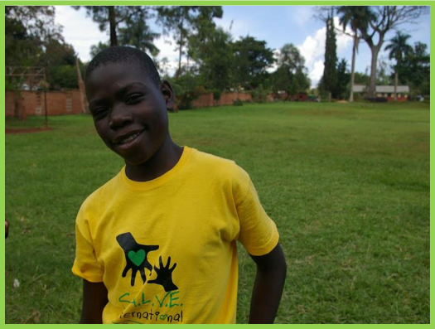

This Session

The lessons engage with learning objectives from subjects including Citizenship, PSHE, English, Geography and Art and Design.

English

**Speaking and listening**: Group discussion stimulate interaction (learning to speak confidently and listen to what others have to say) and give pupils the chance to organise and express thoughts and feelings.

Geography

**Knowledge and understanding:** Helps develop an increased sense of the wider world and similarities and differences between countries, as well as starting to let children engage with human and social features of other countries.

**Skill:** Recaps on engaging with maps at different scales.

Global Citizenship & PSHE

**Knowledge and Understanding**: Lesson as a whole raises awareness of rich and poor, similarities and difference between people and sense of the wider world.

**Skills:** Encourages the development of an enquiring mind, gives an opportunity to begin to state opinion, facilitates empathising and responding to others and making links between our lives and the lives of others.

**Values and Attitudes**: Develops interest in and concern for others, stimulates engagement with social justice and what is right and wrong. Encourages pupils to recognise their role as global citizens who are able to make a positive contribution to the world through their actions.

|  |  |  |
| --- | --- | --- |
| **Activity** | **Resources** | **Suggested Time spent** |
| **Activity 1:**  Start by using the Power-point (Lesson PowerPoint) the recap what was learnt in Lesson 2 and 3, including:   * Recap on maps and Introduction to Uganda and Jinja. * Recap reasons why children are on the street. | Lesson PowerPoint | 5 minutes |
| **Activity 2:**  People around the world often don’t know very much about children who live on the streets and the things they think they know might be wrong. This aims to challenge common myths. Give each pupil two cards, one marked ‘True’ and the other ‘False’. Read out the statements, getting them to hold up either ‘True’ or ‘False’. Then explain the real answer. | True/False cards each (below)  List of statements and answers for teacher (below) | 15 minutes |
| **Activity 3:**  Watch the ‘I am not street video’, explain beforehand that it is a poem made by children who used to live on the street.  http://www.youtube.com/watch?v=shfX1LrAcYc  Discuss with class:   * What are the children in the video trying to tell us?   Brainstorm mindmap on white/blackboard:   * What can be done to help children living on the street have a better future? (Changing attitudes, helping children on the streets to get back in touch with their families, giving these children an education, tougher laws protecting children on the streets and their rights, providing a safe place for children on the streets to come and play etc...) | Access to YouTube  White/blackboard | 10/15 minutes |
| **Activity 4:**  Like all children, children who live on the streets have hopes and dreams for the future. Watch the ‘Looking to the future’ video. http://www.youtube.com/watch?v=8vvnoZZnmXM&feature=youtu.be  Ask pupils to think about what they want to be in the future, then ask them to act it out in a class game of charades | Access to YouTube | 10 mins |
| **Activity 5:**  Return to the PowerPoint to introduce the work of S.A.L.V.E and the importance of education in turning the lives of children living on the streets around. | Lesson PowerPoint | 5 mins |
| **Activity 6/Plenary:**  Ask pupils to reflect on the last 4 lessons and have each table/group come up with 1 thing they will take away (either something they have learnt, what they could do in the future to help children living on the streets etc) | N/A | 5 mins |

|  |  |  |
| --- | --- | --- |
| Statement | True/False | Answer |
| Children only live on the streets in really poor places like Africa. | **False** | Children living on the streets are present in all countries, even in the UK. However, there are many more children on the street in poor countries like Uganda than in richer countries like the UK. |
| Children only live on the street because they want to. | **False** | Some children come to the streets because they want to be with their friends or have more freedom. Most however, are forced to live on the street, either because their families can’t afford to look after them, because they are orphans or because they are abused at home. |
| All children who live on the streets are criminals. | **False** | Some children who live on the streets are forced to steal and do other bad things to survive on the streets, but it is not their fault that they need to do this. It is better to recognise children living on the streets as just children who need help to live a better life. |
| Children who live on the street are not valuable to society. | **False** | Children who live on the streets see themselves as able to make a positive contribution to society despite negative attitudes towards them. And like all children they are valuable human beings who deserve the chance to make the most out of their lives. |
| Children who live on the street have rights just like any other child. | **True** | All children everywhere have basic rights to things like food and shelter. However the rights of children who live on the streets are often ignored or abused. |
| Children who live on the street don’t have a good future. | **True & False** | If children live on the streets their lives are very dangerous and they don’t have the chance to go to school or live healthy, happy lives. However, if these children get the help, support and education they need, they can have a wonderful future just like you and me. |
| Children who live on the street are not my problem. | **False** | Children on the street are too often ignored and treated as invisible. No one wants to take responsibility for them and everyone says ‘It’s not my problem’. Children who live on the streets in Uganda and all over the world are children just like you. They need you to know about them and help them so they can have good lives in the future. |

**TRUE**

**FALSE**

**Accreditation:**  
Photo Credits for teaching pack:

Picture 1: Nicola Sansom, Salve International

Photo credits for PowerPoint presentation:  
Slide 1, 2, 8, 17: (Clockwise from top left): 1. Jonathan McIntosh 2. Tanvirul Islam 3. Zirland 4. Peter Rimar 5. Biswarup Ganguly 6. Esther Dobson 7. Predrag Bubalo 8. Esther Dobson 9. Biswarup Ganguly 10. Sumanth Garakarajula  
Slide 5, 7, 9: Esther Dobson, Salve International  
Slide 11, 14, 15: S.A.L.V.E. International