page1image7093248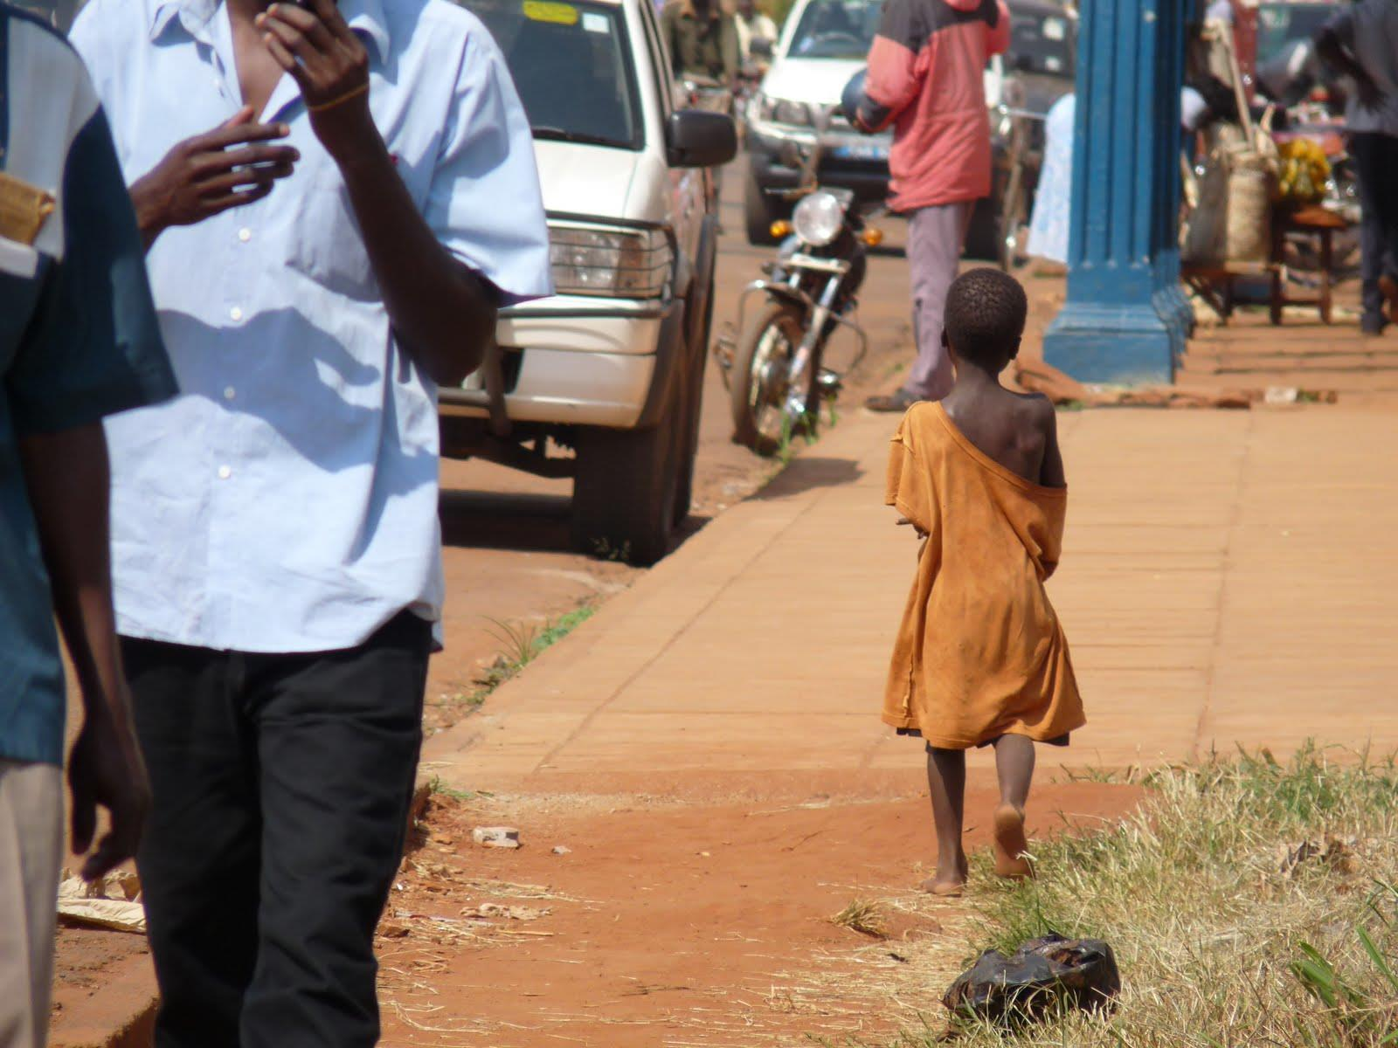

This session

The varied activities within this lesson have been designed to develop cross-curricula knowledge, understanding, skills and values.

English

**Comprehension:** “Jacob’s story” (Activity 2) allows children to develop their comprehension skills by understanding the context and events in a story, and draw inferences from non-fiction texts. This activity also helps children learn to retrieve and record information from non-fiction texts

**Writing:** The worksheet allows children to improve spelling, handwriting and presentation skills. It is also an exercise that teaches them to put their ideas into sentences, use a clear structure to organise their writing and vary their writing to suit the purpose and reader.

Global Citizenship & PSHE

**Knowledge and Understanding**: Lesson as a whole raises awareness of rich and poor, similarities and differences between people, and a sense of the wider world.

**Skills:** Encourages the development of an enquiring mind, gives opportunity to begin to state opinion, facilitates empathising and responding to others, and making links between our lives and the lives of others.

**Values and Attitudes:** Develops interest in and concern for others, stimulates engagement with social justice and explores what is right and wrong.

**Art and Design**

**Knowledge and understanding:** Activity 3 allows space for pupils to begin to understand colour, shape, space, pattern and texture and to use them to represent their ideas and feelings.

**Skills:** Activity 3 also gives pupils the chance to develop their creativity and imagination.

|  |  |  |
| --- | --- | --- |
| **Activity** | **Resources** | **Suggested Time spent** |
| **Activity 1:**  Recap reasons covered in previous lessons of why children may end up on the streets – poverty, bad home relationships, lack of family connections.  Hand out reasons below to each pupil, pupils should draw a picture representing that reason.  Put children in pairs/groups (depending on class size) with the same reason and have them act it out in front of the class. Other students to guess which reason matches.  Create a large mind map style poster of why children end up on the streets with the children’s drawings attached | Print and cut out reasons (below), 1 reason for each pupil  Plain paper, colouring pens/pencils, glue sticks | 20 minutes |
| **Activity 2:**  Read “Jacob’s story” and hand out copies.  Pupils to complete worksheet below | Worksheet provided below  Jacob’s story provided below | 20/25 minutes |
| **Activity 3:**  Like Jacob, children living on the streets have hopes and dreams for the future. Ask pupils to draw their vision of a brighter future for children living on the streets – prompts could include:   * Having safe housing * Friends and family around them * Doing their dream job | Plain paper, colouring pens/pencils | 10/15 minutes |
| **Activity 4/Plenary:**  Ask pupils to reflect on today’s lesson and have each table/group come up with 1 thing they will take away (either something they have learnt, what they could do in the future to help children living on the streets etc) | N/A | 5 mins |

|  |
| --- |
| My mum is mean to me |
| My family are too poor to look after me |
| My auntie tells me I need to get a job to get money for the family |
| I am an orphan, so I don’t have anywhere else to live |
| All my friends live on the streets and they say it’s fine |
| I can make money on the street |
| On the street I can do what I want |
| On the streets I can help my family survive by earning money |
| My family have abandoned me |

Reasons for children living on the streets

**Accreditation:**  
Jacob’s story: This is not an entirely real story – but made up of pieces of several different children’s stories combined to help to protect the identity of the children in question.

Jacob is 7 years old and lives in Jinja, a big city in Uganda. His favourite sport is football and he supports Manchester United. He loves to dance and play games, especially snakes and ladders. When he grows up he wants to be a bus driver. Unfortunately, Jacob ended up living on the street like many children in Uganda.

Before Jacob came to the street he was living with his mum after his dad sadly died. His mum was very poor and was unwell so she was unable to get a job. This meant that she couldn’t afford to send Jacob to school or feed him. She decided to take Jacob to live with his auntie. Jacob’s mum believed that his auntie would be able to take better care of him and she left him there. He had no way of contacting his mum again.

Unfortunately, Jacob’s auntie was also very sick. She already had six children of her own to look after and they lived in a small house, which was one room that was about the size of a normal bathroom in the UK. Jacob’s auntie was too sick to go to work so she sent Jacob to the street to collect scraps of metal and plastic bottles, which he could sell for around 20p a day.

He had to walk for miles to and from town every day. He didn’t get much food or any clean water to drink. When he came home from a day of searching through rubbish dumps, there was nowhere to have a wash. He had to give any money he made during the day to his aunt so that she could feed the whole family. His cousins were jealous of him and annoyed that his aunt had another child to feed so they used to hit him and bully him.

After a while, Jacob decided that it was better to stay in town at night and sleep on the street with the other children. This is very dangerous for any child but especially a child as young as Jacob.

Life on the streets was very hard. Every night he had to find a good place to sleep. People were often mean to him and sometimes would offer him dangerous drugs. He always went to sleep hungry and cold.

In Jinja there is a charity working with children on the streets called S.A.L.V.E. International. They help children who live on the streets by giving them a safe place to stay.

The staff at the S.A.L.V.E. centre where Jacob used to come during the day quickly realised that he had begun sleeping on the street. They took him home to meet his auntie and she explained the situation.

Jacob’s auntie requested that he should go to live somewhere else, like in the S.A.L.V.E. home, until she was better and could care for him and send him to school. Jacob stayed with S.A.L.V.E. until they could find his mum, who luckily was feeling a lot better. He is now living with his mum again and is doing well at school. Let’s hope that one day he can live his dream of becoming a bus driver.

Jacob’s Story: Questions

The story we read was about ............................................................................... .............................................................................................................................................................................................................................................................................................................................................................................................

Where was the story taking place?...............................................................

What is the same between Jacob and you? ......................................................... .............................................................................................................................................................................................................................................................................................................................................................................................

What are the differences between Jacob and you? ............................................. .............................................................................................................................................................................................................................................................................................................................................................................................

What were the big problems that Jacob faced when he was living on the street?................................................................................................................... ............................................................................................................................. ..............................................................................................................................................................................................................................................................

How does the story make you feel?...................................................................... ............................................................................................................................................................................................................................................................................................................................................................................................................................................................................................................................

Who did Jacob go to for help? What did they do? ...............................................

............................................................................................................................................................................................................................................................................................................................................................................................................................................................................................................................

Name:…………………………………………………………………………

